**Suspension Conception**

**Vocabulary :**

* Spring rate : raideur des suspensions.
* Wheel rate : raideur des suspensions rapportées à la roue.

**Goals :**

* Garantee the contact between the tires and the road permanently.
* Tune the car’s handling

**Conception steps**

1. Wheel rate calculation

Ride frequency choosen and the wheel rate based on it :

|  |  |  |
| --- | --- | --- |
|  | Front | Rear |
| Ride frequency (Hz) | 1.78 | 1.67 |
| Wheel rate (N/mm) | 36.4 | 32.2 |

1. Determination of the geometry

Reminder : The Motion ratio defined here is $MR= \frac{Wheel travel}{Spring travel}$.

Hence we have : $MR^{2}= \frac{Spring rate}{Wheel rate}$

The goal of the geometry was to aim **a linear descending motion ratio** with a value of **1.1 in static**. To reach this value, 2D model were used thanks to geogebra :

For the Rear : 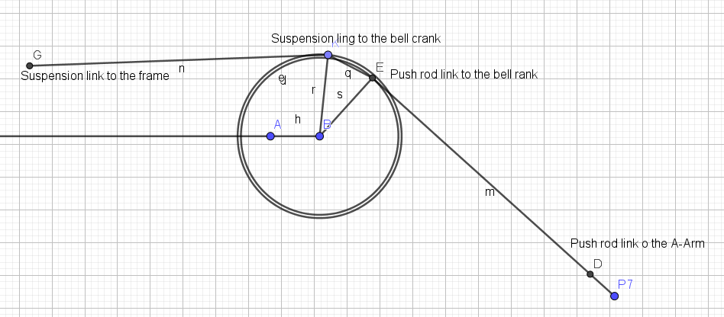

And the front :

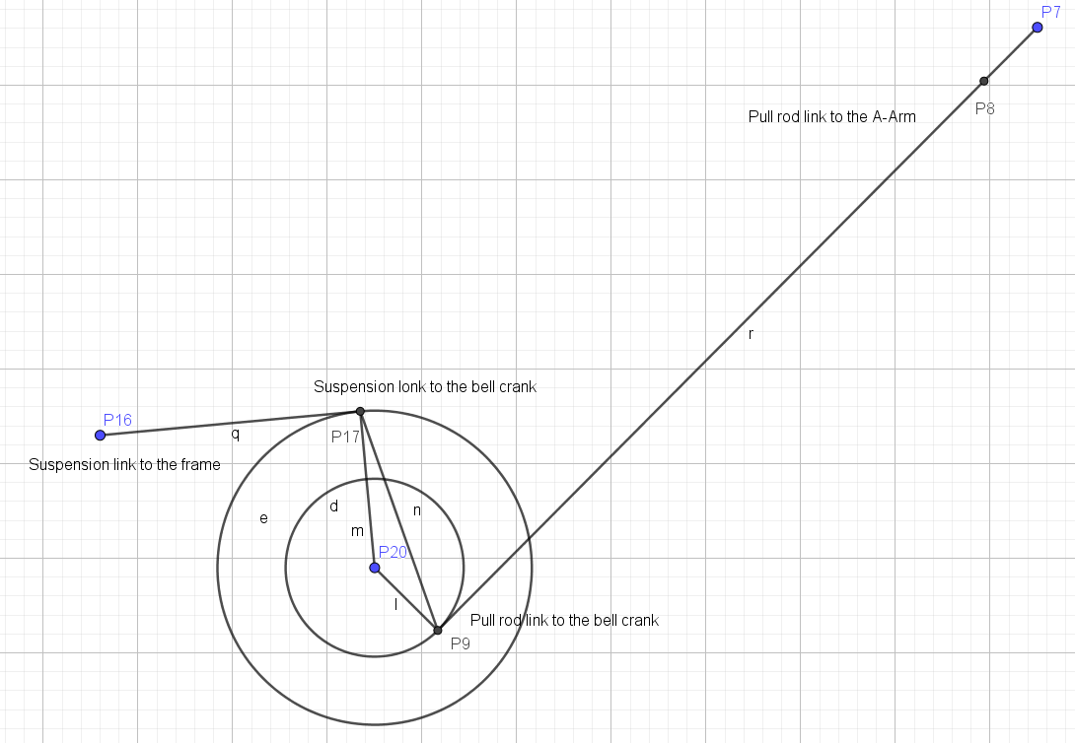

Thislead to the following Motion Ratio curves :

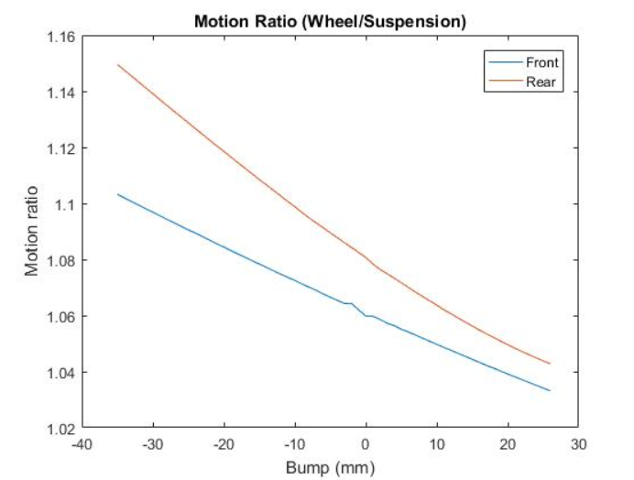

3D CAD model :

